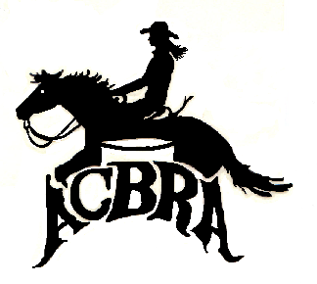ACBRA Board of Directors
Meeting Minutes

September 28, 2019

Board members in attendance in person or by proxy:
Donna Cohn, Cheryl Gatz, Judi Rohr, Cindy Jorge, and Megan Kawkab.

First meeting of the new Board of Directors, held in Ceres, California.

Meeting called to order at 8:15pm.

1. Change of Board members
Leaving the Board: Tracy, Deeana, Cheyenne, Sis
Replacing them on the Board: Cindy Jorge, Judi Rohr, Tammy Hoskins and Cammy Schneider
2. Delegation of duties
Facebook coordinators – Tammy Hoskins and Cammy Schneider
Other directors – Judi Rohr, Cindy Jorge

Meeting adjourned at 8:50pm.

