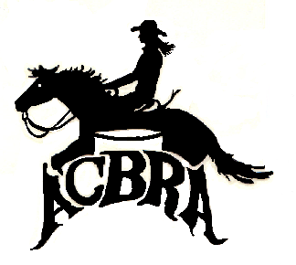ACBRA Board of Directors
Meeting Minutes

October 20, 2019

Board members present in person or by proxy:
Donna Cohn, Cheryl Gatz, Judi Rohr, Cindy Jorge, and Noel Cosca.

Held in Ceres, California.

Meeting assembled at 3:30pm.
- Discussion voluntary stepping down of Tammy Hoskins and Cammy Schneider.
- Those members were replaced with Noel Cosca and Denise Madsen.
- Discussion of the next Board race.
- Discussed possible sponsorship opportunities.
Meeting adjourned at 4:15pm.

